**HISTORY OF SY JELITA**

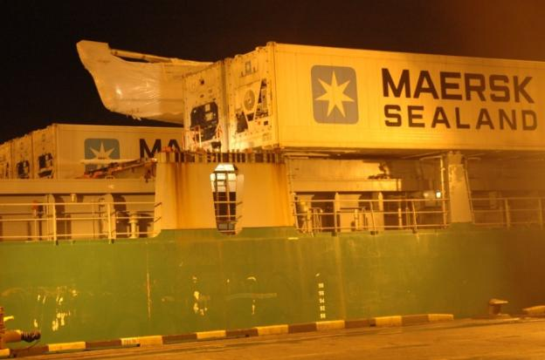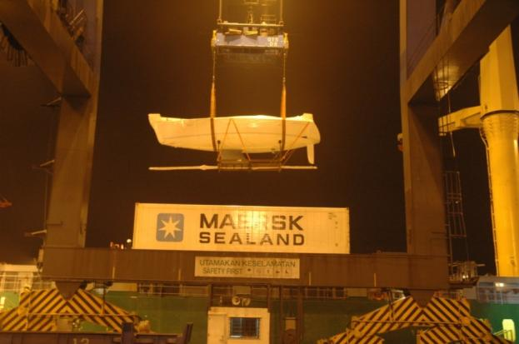

Shipped from Germany to Malaysia in October 2006

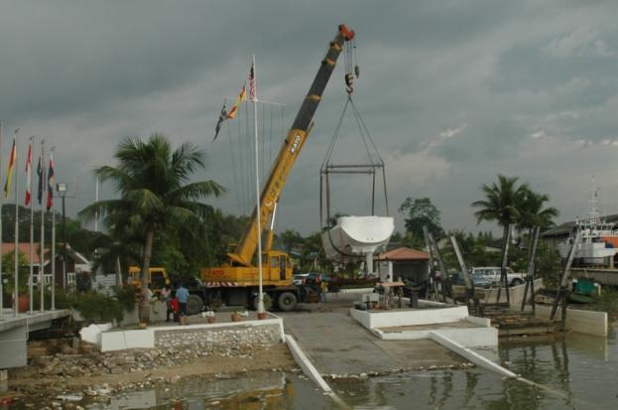

Launched at Port Klang, Malayasia in November 2006.

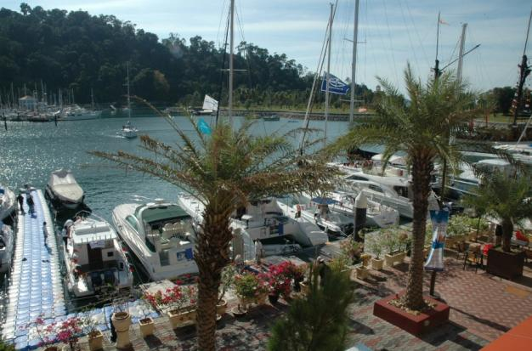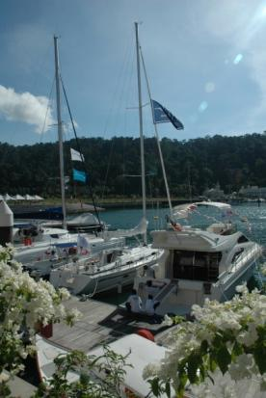

On show at LIBEX 2006 (Langkawi International Boat Exhibition) in November 2006.

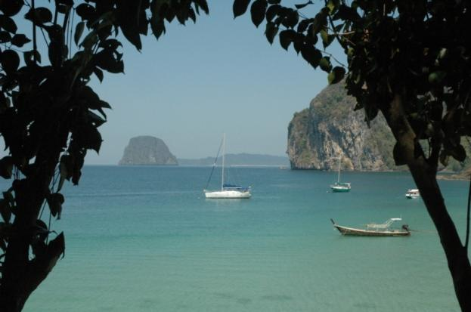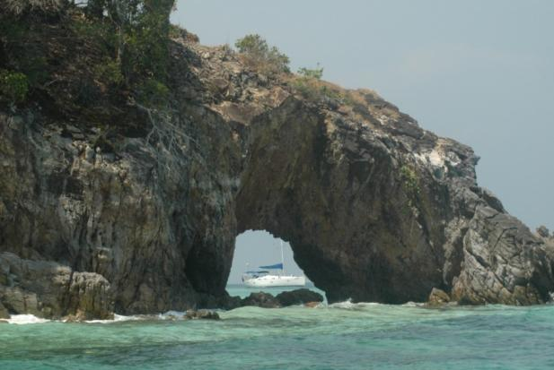

Regularly cruised the beautiful Andaman Sea from Penang to Phuket and the Surin Islands.

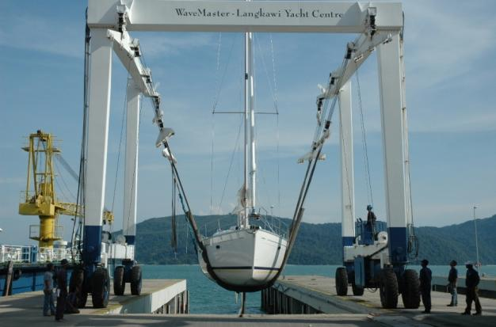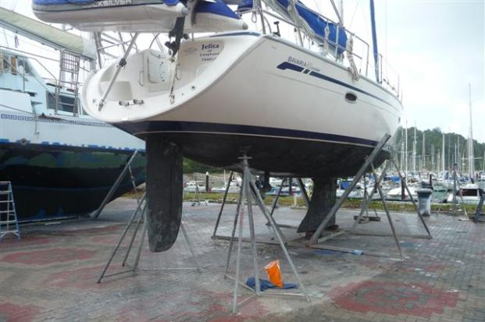

Regularly maintained including anti-fouling every 2 years.

Pristine condition from lots of TLC.

Owner upgrading to new boat.

**ONE OWNER LIVE ABOARD**